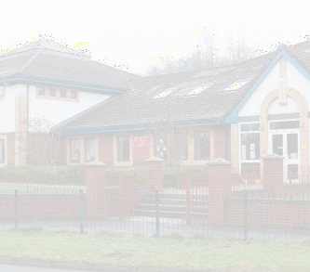
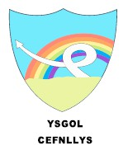

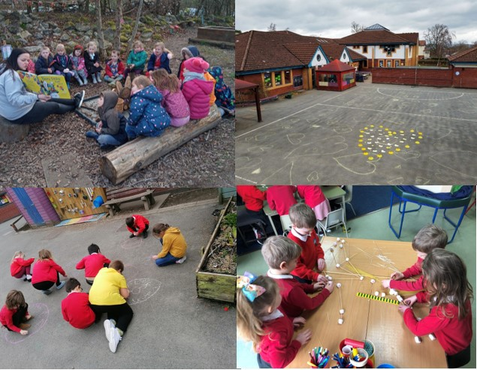
‘Learning today to shape tomorrow’

Ysgol Cefnllys Prospectus
2025-2026
Ysgol Cefnllys, Spa Road East, Llandrindod Wells, LD1 5WA 01597 822297
Website: www.cefnllys.powys.sch.uk Twitter: cefnllys_school
Email: office@cefnllys.powys.sch.uk

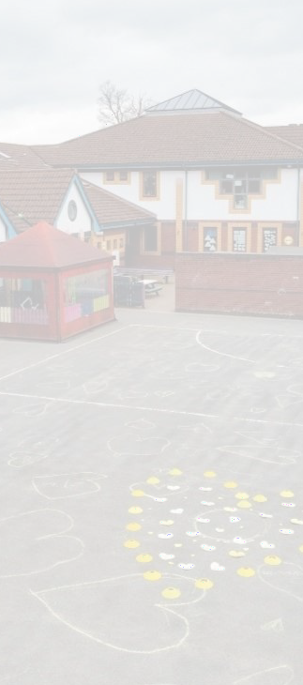
Contents Page
Page
- Welcome
- About the School
- Community Links Friends of Cefnllys Breakfast Club Chwarae Da
- Y Senedd
Home-school Links
- Home-school Links Complains Procedure
- The School Staff
7-8 The New Curriculum
- The School Day School Meals
- Educational Visits
- School Admissions School Uniform
- PE Kit
School Bags
Additional Learning Needs
- Additional Learning Needs Assessment and Reporting Health and Safety
- Emergency Procedures Positive Learning Environment Bullying
- Equal Opportunities Policy Safeguarding
- Absences
Medical Provision
- Money and Valuables

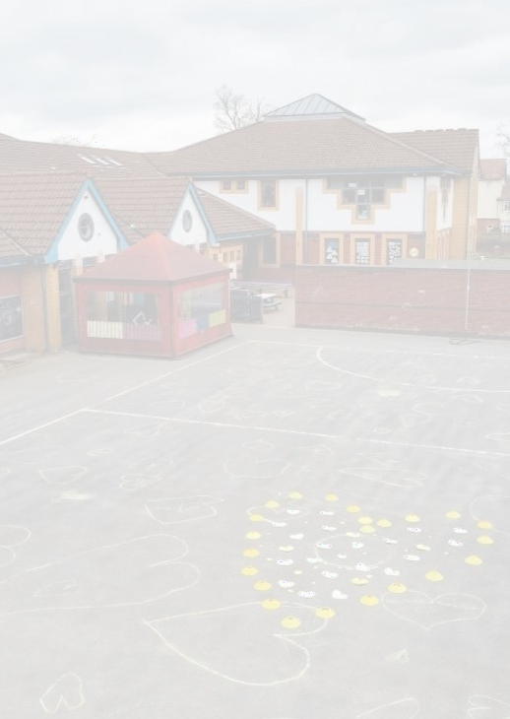
Dear Parent/Carer/Guardian
Welcome to Ysgol Cefnllys

Thank you for taking the time to read our prospectus, we hope that it will give you a brief introduction to our school.

Ysgol Cefnllys is a happy, thriving school that places children at the heart of everything we do. We aim:
- To create a school community of caring, sharing and learning with relationships between children, parents, school staff, community members, other agencies and stakeholders based on mutual trust and respect.
- To develop compassionate and inclusive school community that supports diversity and celebrates differences.
- To create an environment that provides a sense of belonging.
- To develop the children’s thinking skills, independence skills and their capacity to “learn how to learn’'.
- To develop the children’s capacity for the use of a wide range of skills across the curriculum and in their general school life, with focus on Literacy and Numeracy.
- To provide the children with opportunities to develop comprehensive and purposeful Information Communication Technology skills within a range of contexts.
- To provide opportunities to investigate ideas and develop skills and concepts.
- To give children the opportunity to participate in a range of physical and social activities.
- To help children to perceive their own situation in a broader social context through their religious, moral, historical and geographical studies.
- To enable pupils to reach their full potential and develop as rounded, respectful and caring individuals in readiness for the next stage in their education.

Miss Soporova, MEd, NPQH, PBS coach
Tel: 01597 822297
Email: head@cefnllys.powys.sch.uk

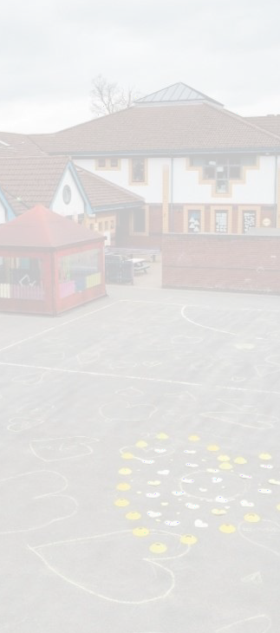
About the School

Ysgol Cefnllys (formerly known as Llandrindod CP School) is situated in the Victorian Spa town of Llandrindod Wells. The new building was opened in 1992 having moved from its previous location in Oxford Road, Llandrindod Wells.
The school has classes, grouped into age expected progression steps, catering for children from 5-11 years. Children are registered in their class base, their learning takes place across the progression step involving regular mixing of staff and pupils.
The school hosts two specialist centres, infant and junior, catering for children with additional learning needs. There are approximately 180 learners on roll (September 2025).
Ysgol Cefnllys is a well-resourced setting. The school is fortunate to have 2 hard surface playing areas and a large school field, an outdoor play area and a running track. Additionally, the school offers early years play area and a wildlife area, which was recently upgraded, using Tesco grant.
The school is within easy walking distance of the local lake and other town's amenities, allowing pupils to further their learning outside of the school gates. All classrooms accommodating for younger pupils benefit from a direct access to outdoor areas. Those allow for sand, water and construction activities to take place throughout the day and fulfil the requirements of Welsh national curriculum for young pupils. Those areas create space for additional learning and challenge areas within the classrooms.
At the centre of the school is a newly refurbished library. Our new library was funded by Friends of Cefnllys and quickly became the heart of the school. We have wide range of books – fiction and no fiction, predominately written in English, however we also have a large section with Welsh books and resources. Books can be borrowed and returned using our newly established library system. The system is manned by our pupils.
Our large school hall is equipped with a screen, speakers and PE operators and equipment. The hall is used for various activities such as assemblies, PE, drama, dance and larger workshops. This space also provides a lunchtime dining area.
We are also lucky to have an outdoor area for older pupils. This area is currently under development, and we are hoping to reopen this section by the Summer term 2026.
Teachers provide a range of clubs which are held after or during school, ranging from choir, cross-country running, book club, games club or forest school activities and many more. These clubs are rotated termly. Each club will specify the age/year groups the club is suitable for.

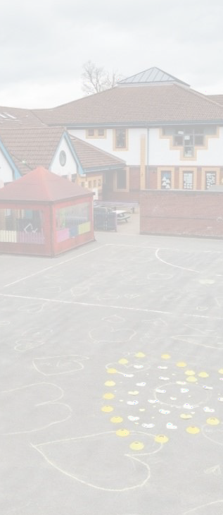
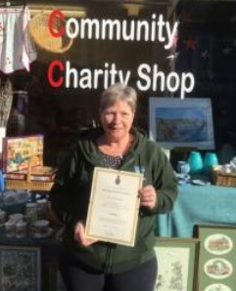
Community Links
The School enjoys close links with the local community of Llandrindod Wells. Parents are given the opportunity to contribute to activities both during and outside of school hours and we welcome those who feel that they have some time to spare or a skill to offer. Our learners take part in a variety of events in the town such as: Remembrance day, the annual carnival and other occasions including Bracken Trust fundraisers and local carol services. As a school, we are always looking for new ways to involve the Community in our work and welcome suggestions from parents and others for new community links.

Friends of Cefnllys
The Friends of Cefnllys have a very important role in our school and are valued stakeholders. As well as promoting friendship and co-operation between staff and parents/carer/guardians, the association has been very active throughout its existence in the field of fund-raising and consequently purchasing many important items of equipment for the school, which otherwise could not have been obtained because of financial constraints. Steph Burton has the management of Cefnllys School Community Charity Shop in the town centre which benefits the school and also many local charities. Additionally, social activities are organised by the
Friends Committee, which serve to strengthen the ties between school, parents/carer/guardians and the community including Christmas Fayre, Easter Bingo, and other events simply for pupil’s enjoyment.

Breakfast Club
We operate a Breakfast club, which is open from 8.00 a.m. until
8.45 a.m. each day. Children are welcome to come to school for a choice of breakfast cereal or toast and a fruit drink/glass of milk.
To book a place, simply ask for a registration form from the school
office. This service is provided at a cost of £2 per child per session, payable in advance or on the day.

Chwarae Da and Holiday Club
Term Times: Tuesday – Thursday
3.30pm – 5.25pm
Holiday Time: 8.45am – 5.25pm

Chwarae Da staff are committed to providing a child-led, secure and happy environment. They offer many activities and opportunities, including craft and messy play, sand and water, a variety of board games and a book corner for quiet times. Additionally, There are a range of other activities on offer including construction toys, train sets and other opportunities for imaginative and role-play.
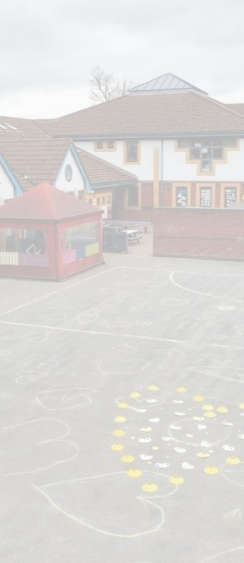
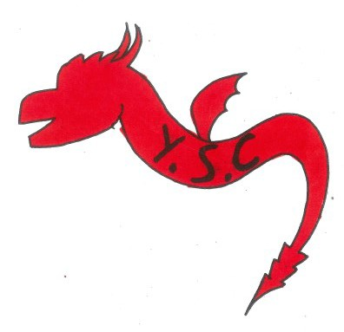
There is a large outdoor area and weaher permitting, this is used on a regular basis for a range of games, loose parts, chalk etc. Day trips into the town to join in local entertainment and events such as those in Victorian Week and other group organised events such as picnics, visits to lake and lake care and walks enhance the provision. During holiday time, there are trips organised to a variety of places such as Elan Valley, Folly Farm, sea side and Cantref. Please do not hesitate to contact us for more details about this provision.

Y Senedd
At Ysgol Cefnllys, we believe it is important for learners to take ownership of their learning and to play a part in school decision-making. We provide many opportunities for our learners to be ethically, informed citizens of Wales and the outside world. Y Senedd is a democratic body, elected by the pupils. There are two representatives from each year group, from Year 2 to Year 6 and they represent the needs and interests of the children. Meetings are attended by a senior member of the school staff team, who feeds back ideas and concerns to the rest of the staff and the Governing Body. Pupils have opportunities to make school-wide decisions such as design of the school library, list of healthy option snacks etc.

Our Senedd logo designed by the learners.

Home-School Links
Communication between home and school is essential to the happiness and success of the children. We encourage parents to maintain a dialogue with teachers and to make contact whenever the need arises. The best time to make contact with your child’s teacher is at the beginning or end of the school day. Our teachers might not be able to respond to emails, messages or answer a phone call during a school day. If you have an urgent issue, please contact the school office and if on the rare occasion there is no one available to answer the phone, you will be able to leave a recorded message on our answer phone.

Michaela (the Headteacher) is always willing to meet with parents/carers/guardians. For urgent discussions, please call the office during school hours. For less urgent matters you can make an appointment, contacting the headteacher directly or via office email.
Letters, posters and other ways of information are sent home on a regular basis. This might include information about dates, events and developments at school. Information is sent out regularly using Teachers2parents text messaging and email service. All correspondence is sent electronically so if you do require a paper copy of letters and information, please let us know on your contact details form or via email to the school office.
The school has a public Facebook profile, which can be accessed by wider community, however each class also has a private account. Only authorized people can access the class page. All classes aim to post photos, videos and information about the pupils’ learning, direction of travel and any achievements, including celebration certificates and progress certificates. You can request to join your child’s class, we only accept follower requests from parents/carers/guardians with the correct parental rights. Permission is sought from each parent/carer to include their child on Facebook /photographs on an annual basis so please let us know if this is something that you do not wish your child to be included in.
Child-let planning/map is shared with families via Facebook. This will inform you of the topic content and ways in which family members or friends could be involved - we encourage parents to discuss their child’s learning with them at home.

Complaints Procedures
We hope that you will be happy with the education and support that your child receives in Ysgol Cefnllys. However, if you are dissatisfied in any way, you should first discuss the matter with the class teacher or the Headteacher. If you are still not satisfied, there is a complaints procedure and the policy can be found on our website or is available from the school office.

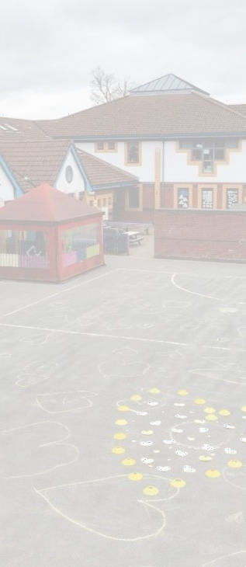

Class structure

All our classes are mixed year groups. This allows for nurturing relationships, transitions within classes and offers greater opportunities for join-up working. The mixed year groups system also provides person-centered, and interest driven education for all.
The School Staff

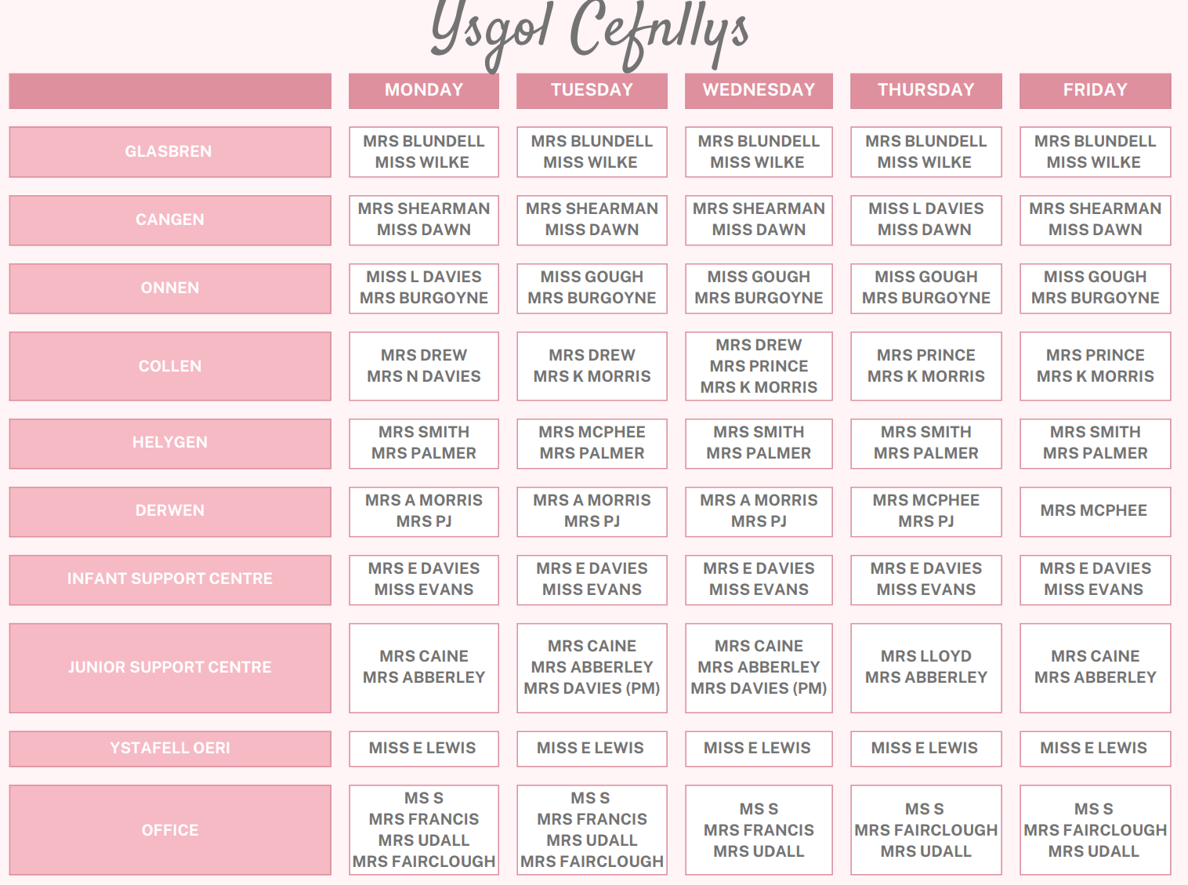

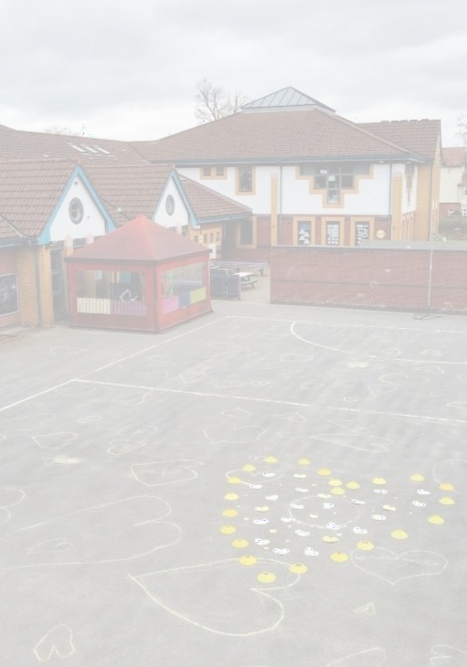
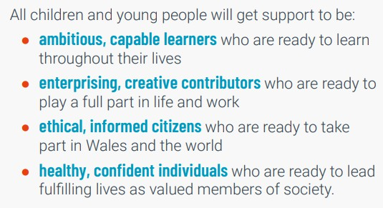
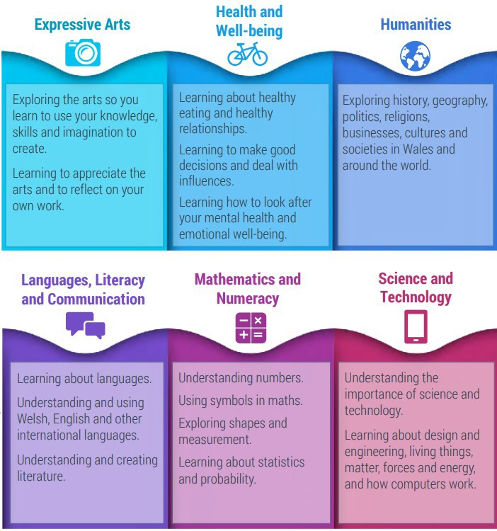
The New Curriculum
The Welsh Government have introduced a New Curriculum across Wales. For more information, visit: a-new-curriculum-in-wales-a-guide-for-children- young-people-and-families.pdf (gov.wales)
Our website also provides information on the curriculum structure and development as well as the rational for the changes implemented.

It’s designed by teachers.
Teachers will plan the lessons and learning that will help your children be ready for their future. We have worked with other local schools and have designed bespoke curriculum for Ysgol Cefnllys which fulfils the Welsh Government requirements. The curriculum follows the direction of pupils’ led learning, guided and supported by enabling adults. We reflect on our cohort, societal changes and the diversity within the school community and review our curriculum offer regularly. Our aim is to develop our pupils’ learning journey in the most responsive way.

It’s built for all children.
The new curriculum will support children through creative lessons that have real-life meaning. It will help them to reflect and think about what they’ve learnt and move f
The foundation of the new curriculum are the four purposes.
Ysgol Cefnllys has personalized the purposes. Please meet
Ethical Ethel
Healthy Hugo
Enterprising Edwards
Ambitious Aurora
As well as Literacy, Numeracy and Digital skills, there will be 6 areas learning and experiences:

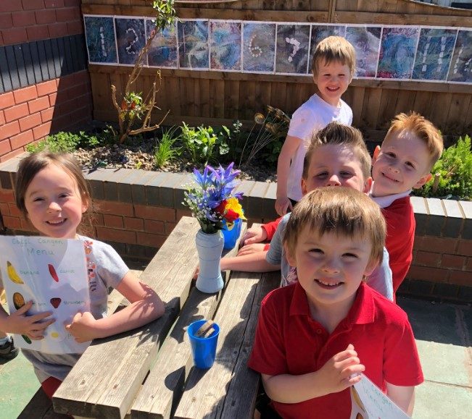
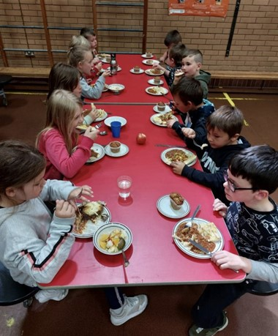
The School Day
The school day begins at 8.55am and ends at 3:30pm. All children arrive at the school gate which opens at 8:45/8:50 and then they make their way independently to their classes. We ensure that at least 2 members of staff is at the school gate/school playground each morning to greet the children and support a positive transition to school.
There is a short mid- morning break for which the children are able to bring healthy and reasonably sized snacks. We ask that you adhere to the children-led school’s healthy eating policy and provide healthy foods for your child. The children worked hard on a list of food we believe is acceptable for healthy eating school. The list can be located on our website. Chocolate and sweets are not permitted for snack and crisps are strongly discouraged, unless the child has specific diary difficulties. This must be agreed by the senior leadership team. Children are expected to eat their snack in the classroom, providing a healthy and calm environment while eating. After morning snack children of all ages are able to socialize, play games, and just relax and rest before returning to their classes for their next lesson.
Lunch break is from 12:15pm until 1:15pm for all children. All children have the opportunity to play outside before or after their lunch.
As we have a whole school playtime in the morning and at lunch time, our children can play and interact with their friends, relatives, neighbours who might be members of a different class. This facilitates the feeling of belonging and connection. Our breaks are learning opportunities led by the pupils and provide fundamental skills required to navigate the social aspects of our day-to-day life. Playtime provides out pupils with opportunities to work on their resilience, teamwork, negotiation, compassion, acceptance and self-advocacy. Play/learning through real life experiences is the core of learning and must be acknowledged as such.
There is also a short afternoon break for the younger children.

School Meals
We have meals which are provided by Powys Catering and are cooked on the premises. All children in primary setting eligible for Free School Meals under the Welsh Government scheme.
Seasonal menus are provided by Powys County Council to the children and special diets can be catered for by arrangement. Please see the Powys County Council website for an up to date menu. Children may bring in a packed lunch, if they prefer.
Please note: We are a nut free school, therefore no products containing peanuts or any other nuts must not be brought onto the school premises.

Educational Visits
It is a priority in Ysgol Cefnllys to provide children with first hand contextual opportunities for learning, particularly in areas they may not otherwise experience. This is why curriculum visits and residential expeditions are opportunities given to children in order to gain valuable social and educational experiences.
Each year, classes undertake visits to a variety of locations in order to enhance children’s learning experiences. Where possible, visits are related to the themes that children are studying in order to develop their understanding and contribute towards their classwork but residential experiences are also offered to older children, which as a school we feel are incredibly valuable social experiences.
With only some exceptions, the school is not permitted to make charges to parents/ carers for educational activities within school hours or fulfilment of the National Curriculum. However, the school can ask for voluntary contributions towards costs and costs of residential trips are not covered, unless children are FSM, therefore half of the cost will be covered. Parents are asked in advance to make a voluntary payment for their children to take part in special activities. The school reserves the right to withdraw activities should contributions be insufficient. Please see policy on website for further information.

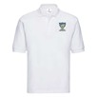



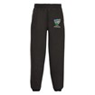

School Admissions
Parents who are considering sending their children to Ysgol Cefnllys are welcome to contact the school office and arrange a visit to look around and meet the staff. All admissions for Ysgol Cefnllys are administered by the Local Authority. The publication ‘Primary and Secondary Schools Information and Admissions Arrangements’ is a comprehensive guide to admissions across Powys Local Authority Schools and can be found on Powys Website.
Alternatively, the Education Authority’s Principal Officer Admissions & Transport, may be contacted on (01597) 826455.

School Uniform
We encourage all children to wear the School uniform because it contributes significantly to the ethos of our school. We feel that wearing uniform:
- makes children feel equal
- looks smart and attractive
- makes the children safer - they are easily recognisable when outside the school premises.

Black/Grey trousers, shorts, dress or skirt
White Polo
Red Sweatshirt or Jumper
Red/White gingham dress
Red hoodie

Shoes are important and should be such that children are able to run around with safety on hard and field play areas. Open toed sandals and high-heeled shoes can be unsuitable, unstable and dangerous in play situations. Outdoor footwear is not permitted indoors from year 2 to 6 and therefore we encourage all pupils to have a pair of indoor shoes/pumps.
Uniform can be ordered or purchased embroidered with the school logo or plain coloured clothes can be worn. Information on this is available from the school/ office.

PE Kit
All children come into school in suitable clothing for their class timetabled PE sessions. Everyone will need trainers or pumps, a pair of shorts, (or in winter tracksuit bottoms) and a T-shirt in the school colour (red/white).
If your child is unable to participate in PE lessons, please send in a note stating the reason. Swimming sessions for children happens on a rotational basis and are part of the Welsh curriculum, and you will be informed of dates and sessions in advance.
Please ensure your children has appropriate swimming kit on the designated day.
We discourage all forms of jewellery in school for safety reasons. Only stud type earrings should be worn and these must be removed for PE, Swimming and Games activities for Health and Safety reasons.

School Bags
All children will be given a school book bag when they begin their time at Ysgol
Cefnllys. Children often bring a separate rucksack for any additional items that they wish to bring to school. It is important that all items brought in from home are clearly labelled. Child’s first reading bag is provided by the school.

Additional Learning Needs
Children in Ysgol Cefnllys are treated very much as individuals and as far as possible we cater for their individual needs. All teachers provide differentiated work to cater for the needs and abilities of all children. All children are given work at an appropriate level to enable them to fulfil their true potential and this is inclusive of those who are particularly gifted. Although we are a two storey school, we have a lift that allows wheelchair users to access all areas of the building.
When children first come to school they will undertake a baseline assessment – within first 6-8 weeks. Children aged 7 upwards take the Welsh personalised assessments in Literacy, Numeracy and Reasoning. These results, together with ongoing teacher assessment, help to identify children who are not making appropriate progress in Literacy and Numeracy. Children with ALN will provided extra help either within the class or in small intervention groups. Each child with ALN will have own ALN provision map, stating what support is needed to support their specific needs. The school has ALNCo (Additional Learning Needs Co-ordinator), Mrs. K. Caine. If you need to contact her, please email to the school office.

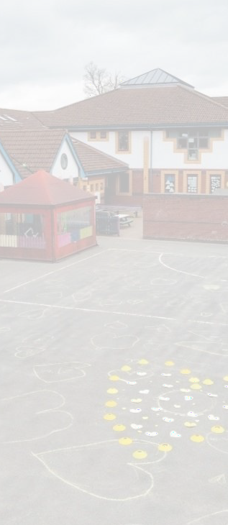
Parents are always informed if their child needs extra help and at that stage the child is put on the school's universal learning provision plan.(ULP) All children accessing universal learning provision have their progress closely monitored.
On occasions, children are referred to outside agencies for further professional advice. If this is necessary, parents will be informed and discussions will be held before such help is requested. At this stage the child may have an Individual Development Plan (IDP), which is reviewed annually.
Parents who have concerns about their child's progress in school should contact the class teacher in the first instance.

Assessment & Reporting
Informal teacher assessment of individual children takes place continuously as an aid to planning. It often takes the form of informal observation and is based upon the interaction between teacher and learner that characterises good class teaching. We are always willing to talk to parents about the progress that their child is making and the next steps they need to take in their learning.
Parents are welcome to discuss their child’s development with teachers at any time, however, reports in the form of “Learning Journals “are produced by the class/learner to inform parent/carers of their learning and these are termly. A final report is produced in the Summer term. Opportunities for parents/carers to consult with class teacher are given during the school year.

Health and Safety
The school grounds and buildings are subject to the same rules as other public buildings in terms of health and safety. The school carries out regular Health and Safety checks throughout the year. We are also subject to health and safety inspections by the local authority. The school takes Health and Safety seriously and addresses any concerns in an effective and appropriate manner. Any concerns regarding health and safety should be raised with the school as soon as possible and are important to help us to remain safe for all stakeholders.

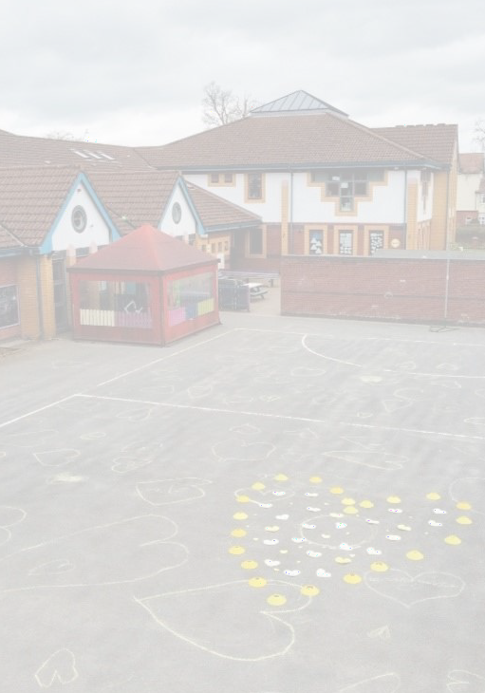
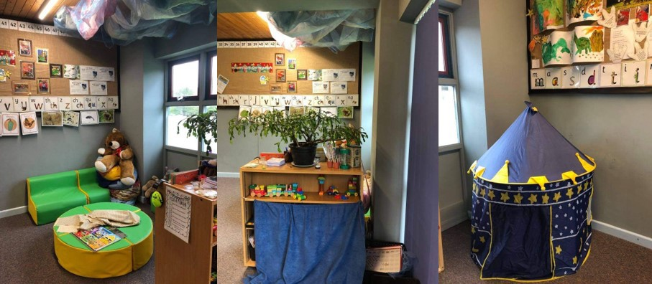
Emergency Procedures
We maintain a database of telephone numbers of parents and carers which we use to contact in case of an emergency. To keep this list up to date and to ensure that we can contact you should your child be taken ill in school, please notify both the class teacher and the office should any information change.

Positive Learning Environment
Ysgol Cefnllys wishes to provide a school environment that is safe and stimulating for the children in our care. In order to ensure that this is so, we have introduced procedures to create a calm, secure and happy working
environment for all. The approach is holistic and includes a range of elements: Play Therapy, Trauma Informed Schools practices, Restorative Approach, Aces understanding, Positive Playtimes, Kidscape, Yoga, Mindfulness, ELSA.
We have agreed ‘Ways of Being’ (see appendices) that set out, in general terms, how we expect our learners to behave in school and on visits these are agreed by parents, carers and guardians and learners in our Home School agreement. These ‘Ways of Being’ are ‘Safe Ready and Respectful’ and sit well beneath our school motto ‘Learning Today to Shape Tomorrow’.

Bullying
Incidents of bullying in Cefnllys School are extremely rare, but in any community where children are growing up and learning to work alongside others, they do occasionally occur. It is important that parents notify the school as soon as they think that their child is having any issues so that they can be dealt with immediately. All allegations of bullying are taken extremely seriously.
Regular assemblies and lessons stress the importance of kindness to others and set the standards of behaviour that we expect the children to adhere to.

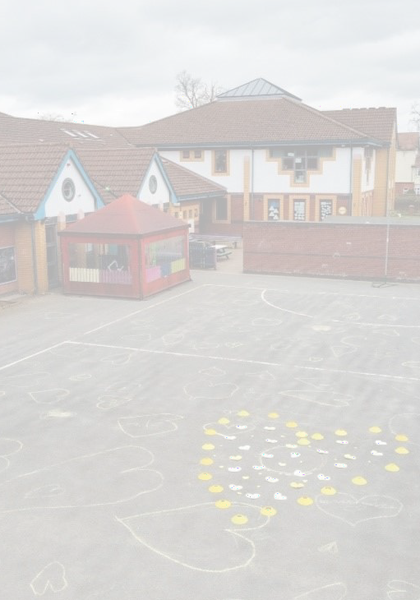
Equal Opportunities Policy
At Ysgol Cefnllys:
- We do not discriminate against anyone, be they staff or learner, on the grounds of any protected characteristic in accordance with the Equalities Act 2010.
- We promote principles of fairness and justice for all through the education that we provide.
- We ensure that all learners have equal access to the full range of educational opportunities provided by the school.
- We constantly strive to remove any forms of indirect discrimination that may form barriers to learning.
- We ensure that all recruitment, employment, promotion and training systems are fair to all, and provide opportunities for everyone to achieve.
- We challenge stereotyping and prejudice whenever it occurs.
- We celebrate the cultural diversity of Wales and the UK and show respect for all minority groups.
- We are aware that prejudice and stereotyping is caused by low self-image and ignorance. Through positive educational experiences and support for each individual’s point of view, we aim to promote positive social attitudes and respect for all.

Safeguarding
The school operates a thorough and comprehensive safeguarding policy to ensure the well being of all of our children. This includes our Child Protection and Safeguarding Policy (available on the website). All parents and carers should be aware that if the school has any concerns regarding the safety of a child, we would not hesitate to make a referral to Social Services.
The Designated Senior Person for Child Protection at this school and The Designated Teacher for Child Protection at this school is:
Miss Michaela Soporova

The Deputy Designated Persons for Child Protection at this school are: Mrs E. Smith, Mrs. A. Shearman, Mrs. A. Morris, Mrs. K. Caine

The Designated Governor for Child Protection at this school is: Mrs. S. Collister – Chair of Governors

Absences
If you know in advance that your child will be missing any part of a day’s schooling, or if a late arrival or an early departure is needed, please let us know in advance by either sending a note to the class teacher or calling the school office. Please note that without an acceptable reason for non-attendance, all absences will be recorded as unauthorised. Unauthorised absences appear on a written report which you will usually receive at the end of each academic year; we are also obliged to inform the local authority of any ongoing absences or lateness. No absence due to holidays will be authorised and is therefore recorded as unauthorised.
Please call the school before the start of the day to inform us if your child is absent due to illness. For safeguarding reasons, the school will telephone parents within an hour of the start of the day for any absent child that we have not received a message for.

Medical Provision
The school staff are not legally obliged to administer any medication to children during the school day. However, in exceptional circumstances, where medication is essential and where it is difficult for parents to come into school to administer the medication to their child, the staff may agree to do so.
Requests for administering medication must be made to the Head Teacher, who will make the decision on whether medication can be given.
Parents will be required to sign a form absolving the teacher of responsibility in such a case. Medical permission forms can be obtained from the office.
Asthmatic children who need to carry inhalers to be used in school will also need their parents to sign a form to allow them to do so. Any medication brought into school should be in the original packaging and clearly marked with the child's name and handed to the office on arrival at school.
Should your child become ill during the school day, we will need to get in touch with you and ask that you provide us with your mobile, home and work telephone numbers and an emergency number for someone local who may be contacted if you are not reachable. Minor accidents will be treated by a qualified First Aider. All accidents are recorded and in the event of more serious accidents, necessary action will be taken parents will be contacted.

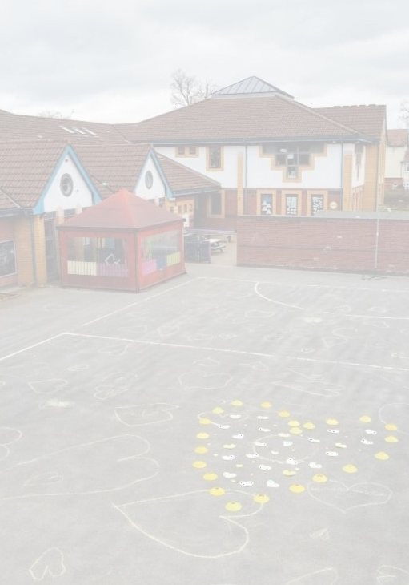
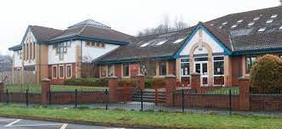
Money and Valuables
We discourage children from bringing in any items of financial or sentimental value to school. If such items are contributing to the child’s learning, we take a keen interest but cannot be held responsible if these are damaged or lost.
Mobile phones are discouraged and if for any reason your child requires a mobile phone in school, it must be handed to the class teacher first thing in the morning.

Thank you for taking the time to read our school prospectus. If there are any areas that you would like clarified or if you would like any further information, please do not hesitate to contact the school.
Miss Michaela Soporova Head Teacher

