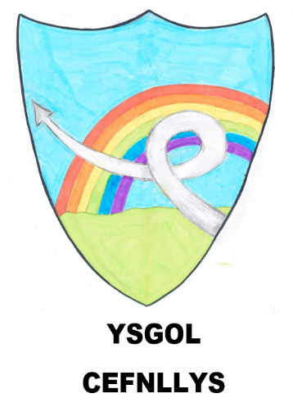
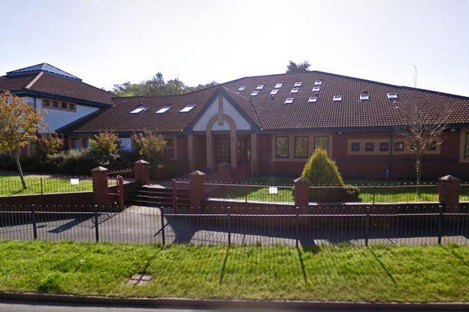

Welcome to our School

Hello! Our names are Mrs Blundell & Miss Wilke. We are going to be your new teachers when you start school.

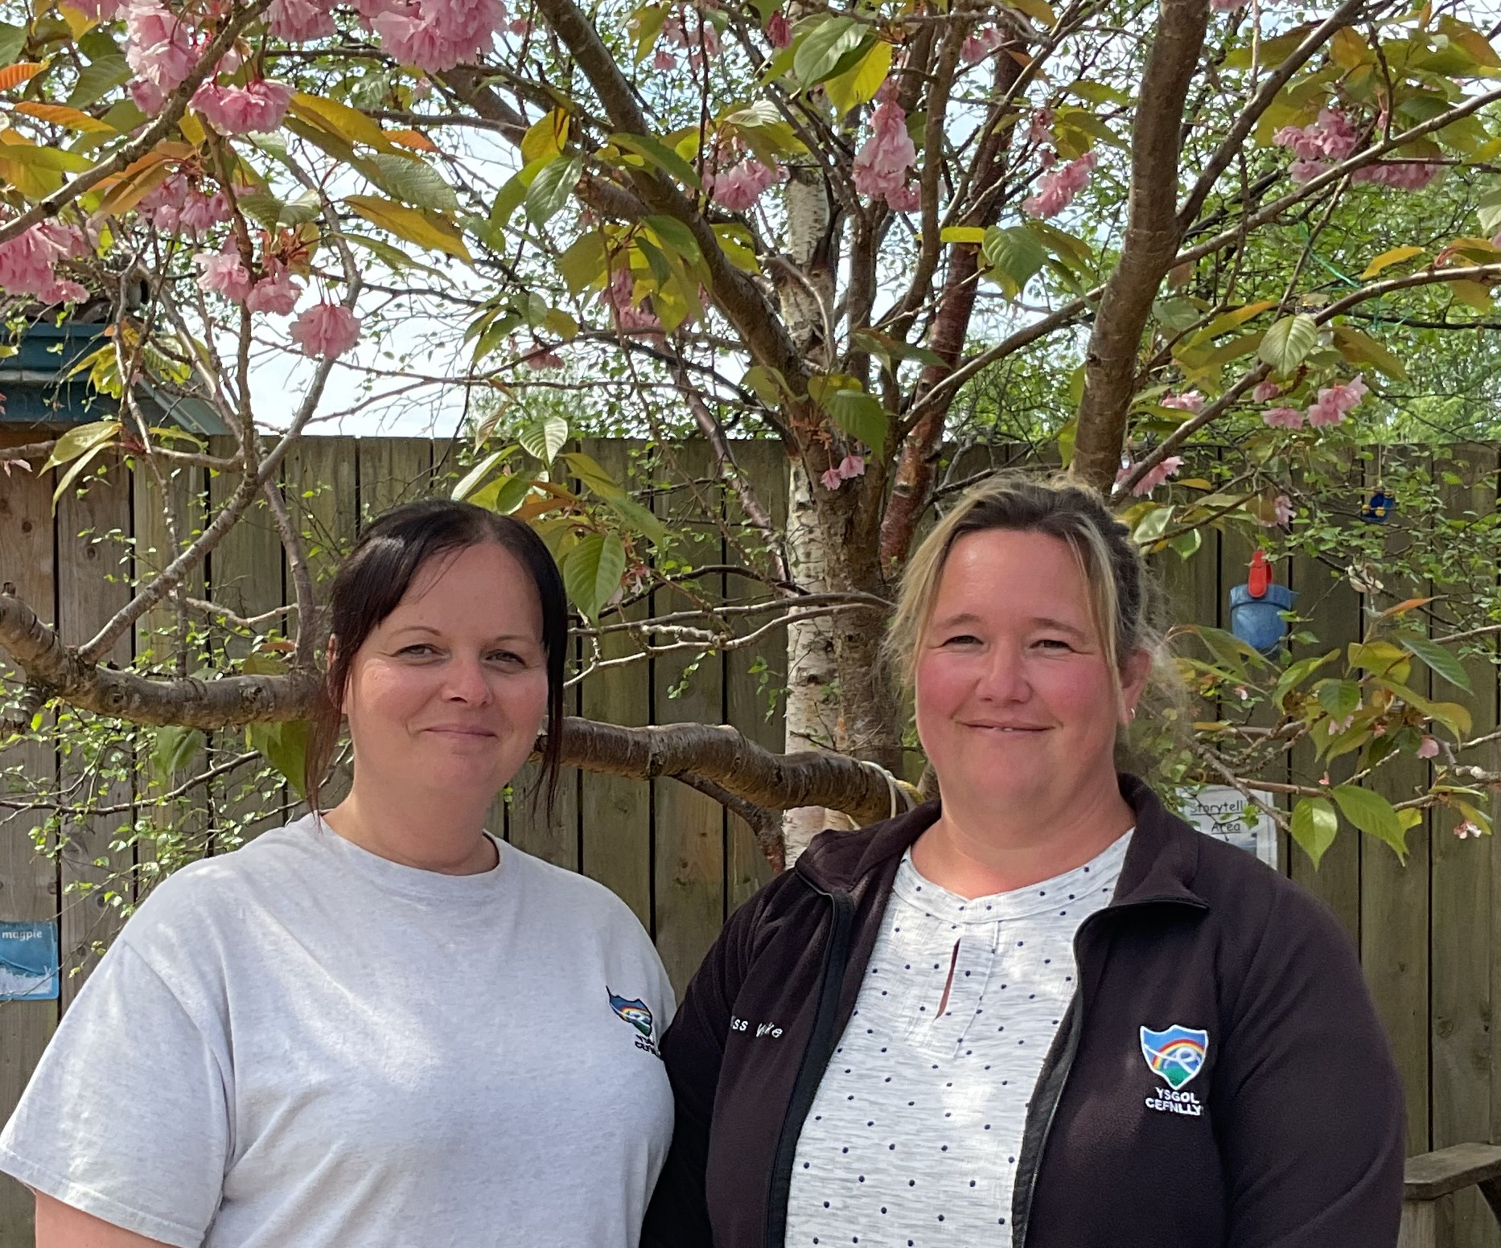
Mrs Blundell & Miss Wilke

We can’t wait to meet you all ,and show you all the lovely things in our classroom and our outdoor play areas.

These are our Class goldfish. We will all help to take good care of them.
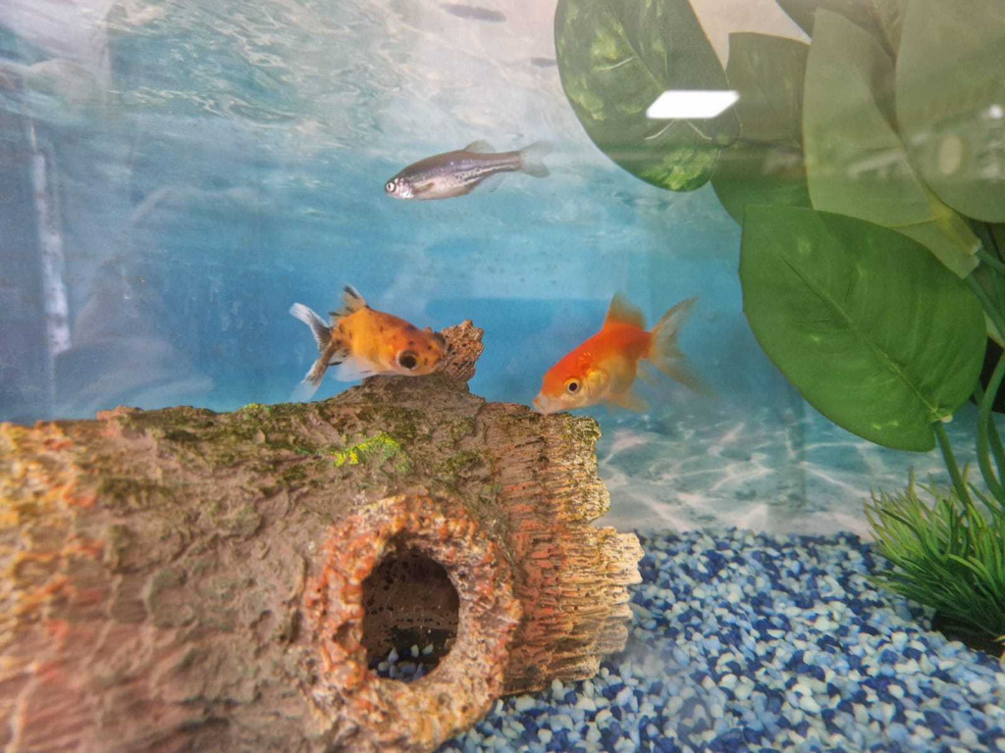

They are called Stormzy and Goldie. We also have four silver Danios.

This is what our school looks like.

Our school is called Ysgol Cefnllys, and we have lots of fun here.

This is our school logo, it will be on your school jumper.

This is our Reception classroom, called Dosbarth Glasbren (This means Saplings class in Welsh).
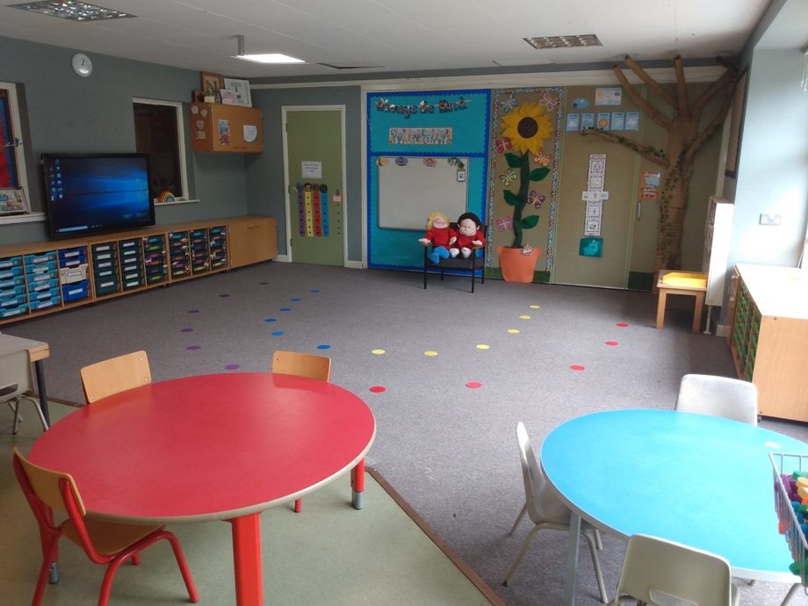
Molly and Wally are here to show you what lovely things we do during the school day.

Molly and Wally are wearing their school uniform. You will have school uniform too. Don’t they look smart!
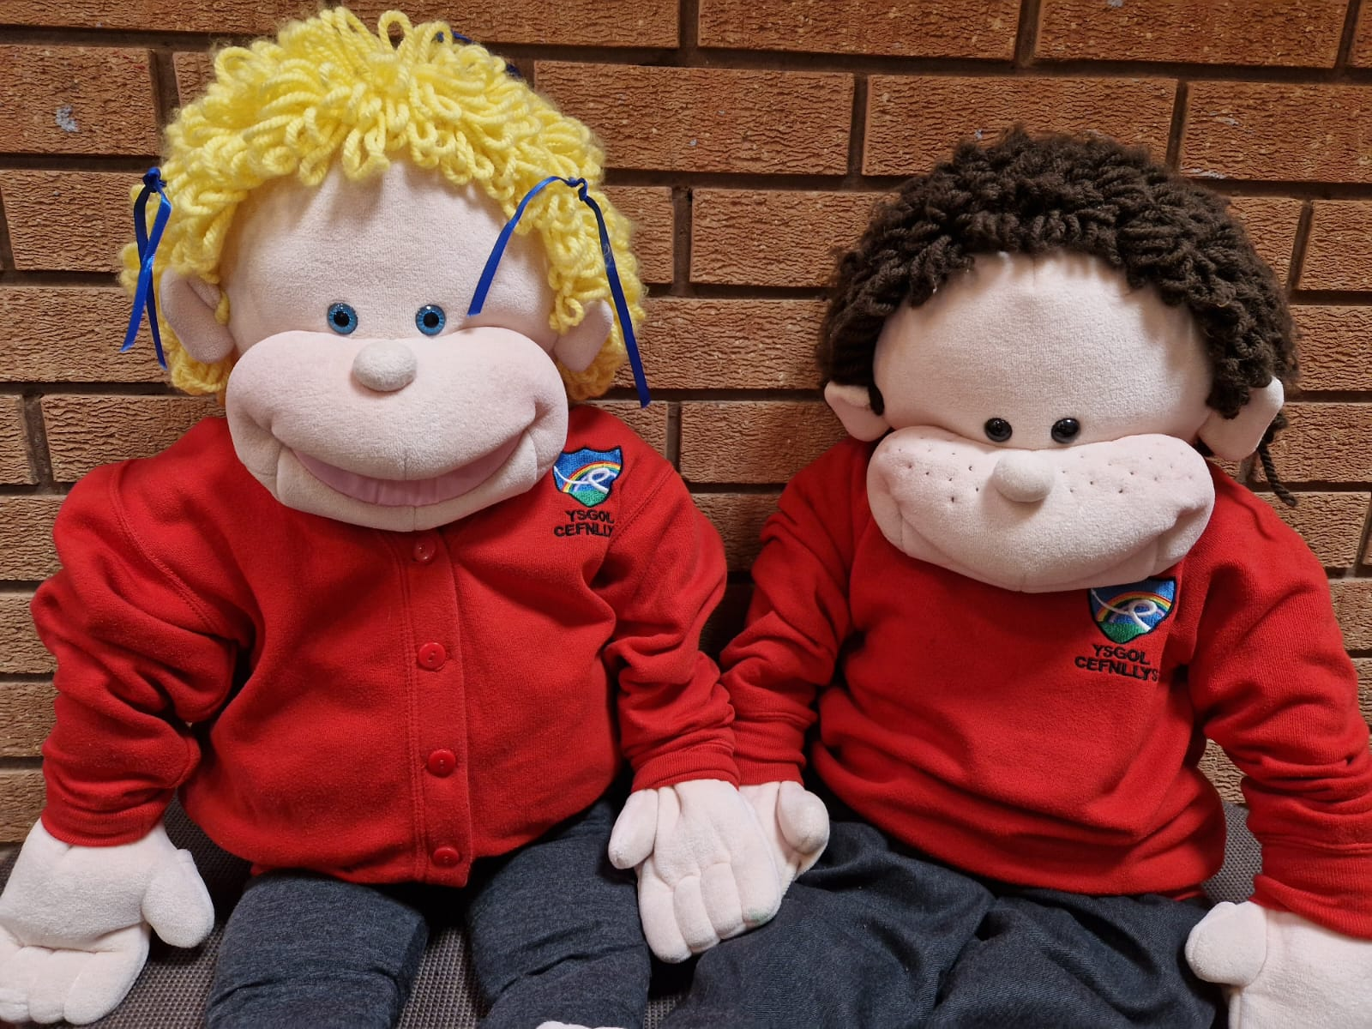

They have red school jumpers and black/grey trousers or a skirt/dress. In the summer you can wear shorts or a dress if you like. The main thing is that you are comfortable and can go to the toilet easily.

Here are Molly and Wally having their snack before our morning playtime.

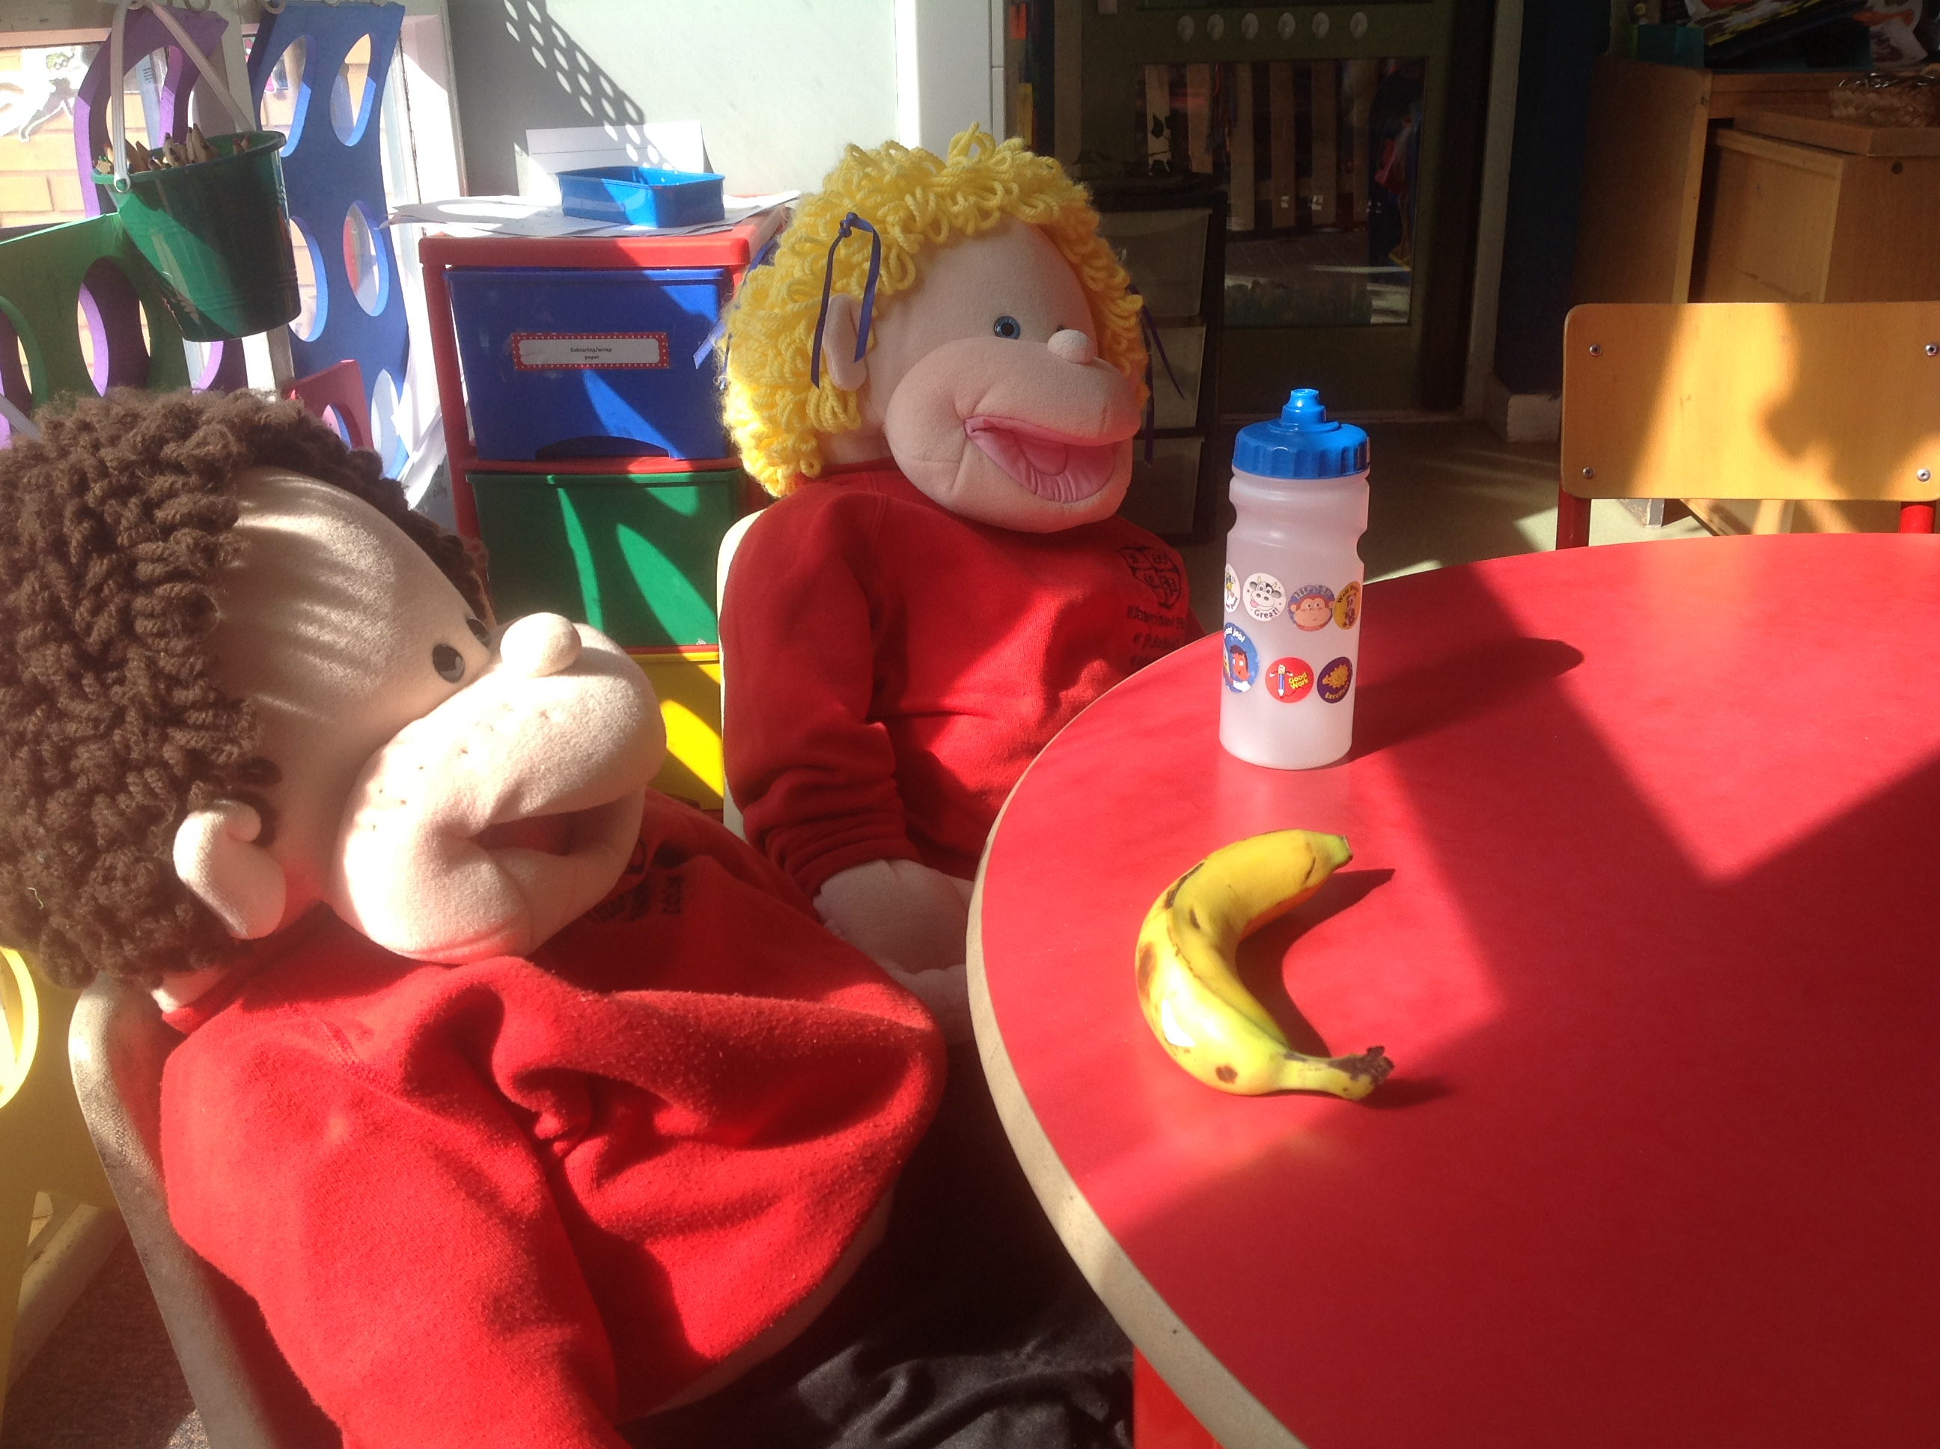

And here they are playing in the construction area.
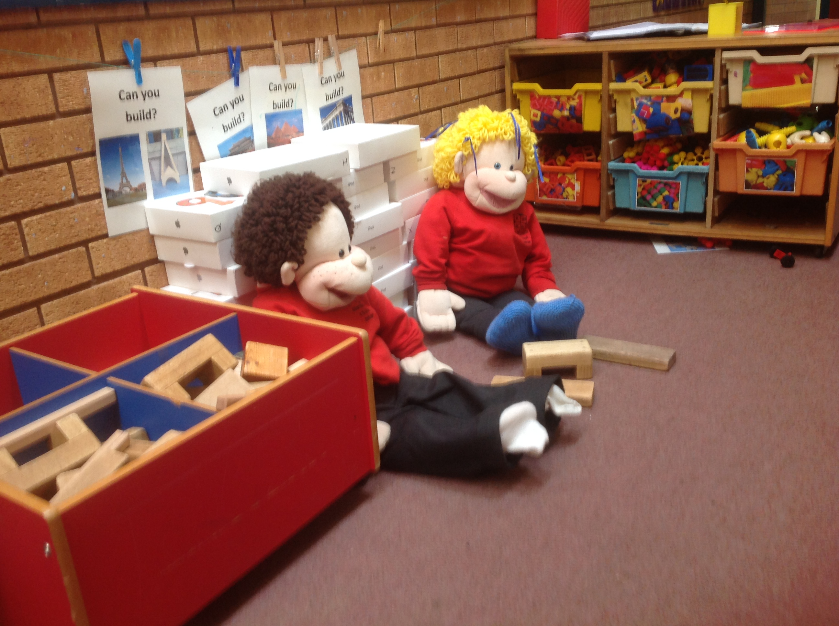

We eat our lunch in the hall. You might bring a lunchbox or have a school dinner.
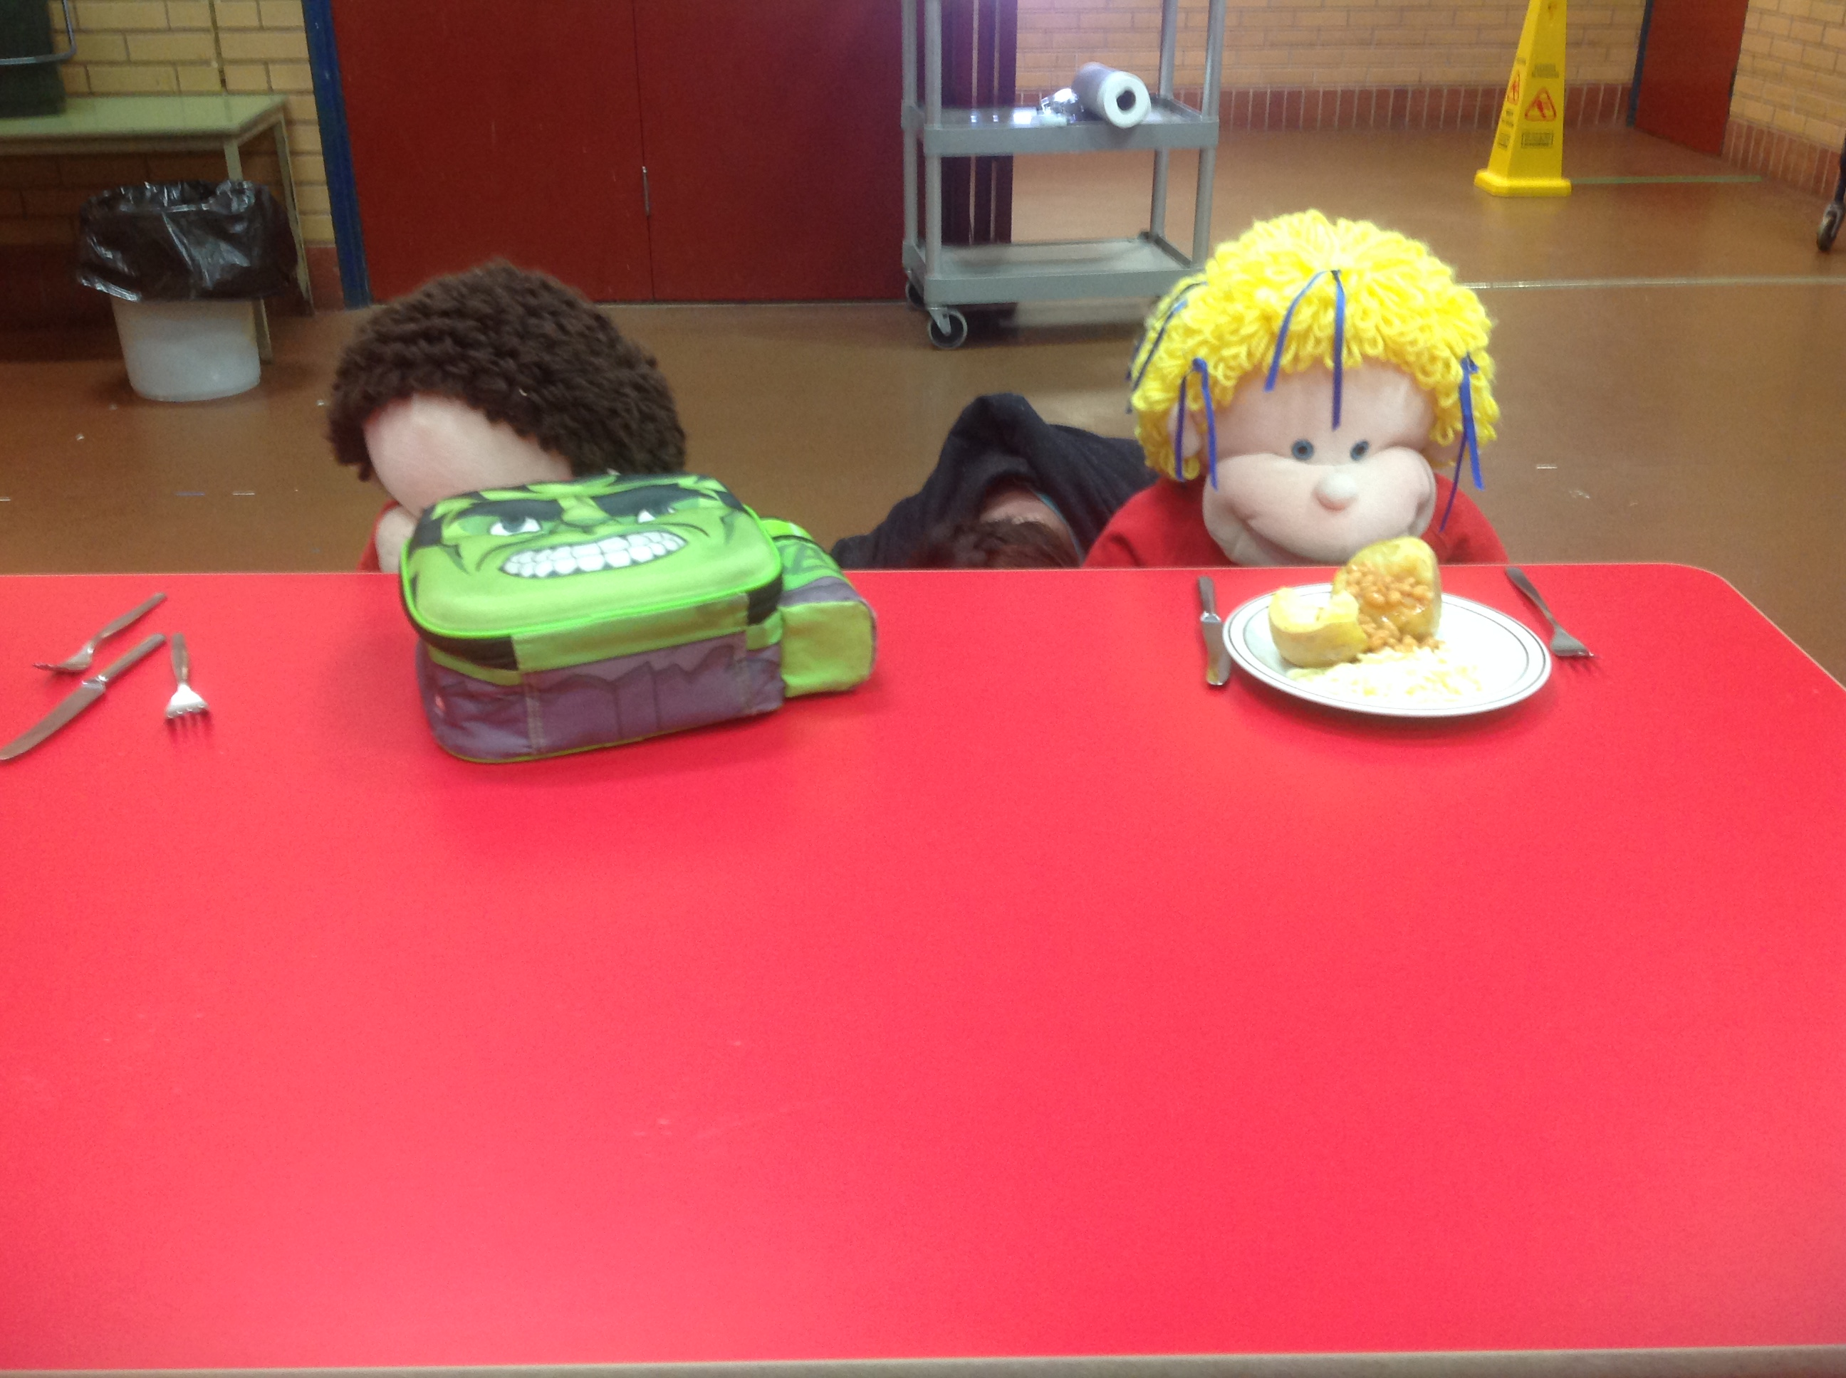
After lunch we play outside.
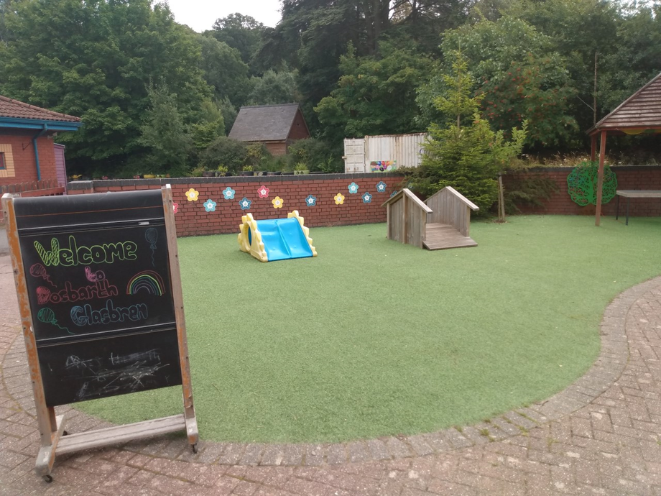

Here we are playing on the field.
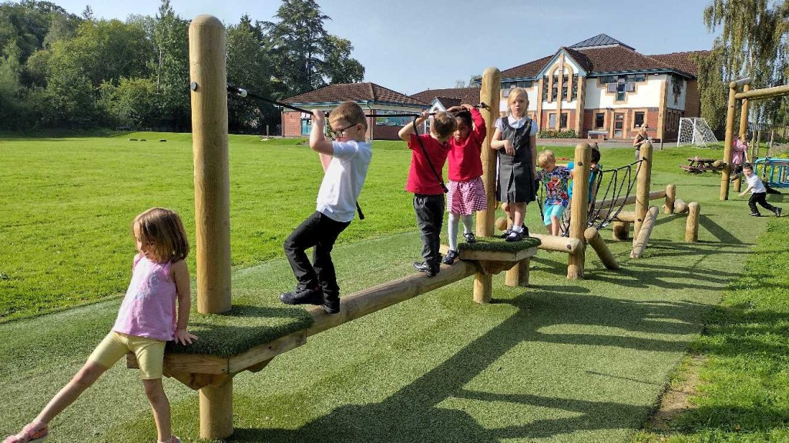

We have lots of bikes too.
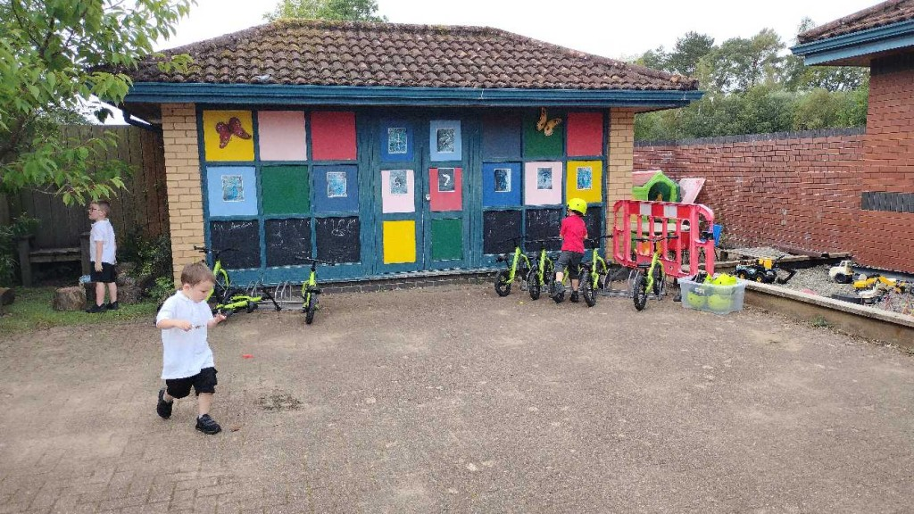

We also have a lovely wild area to play in.
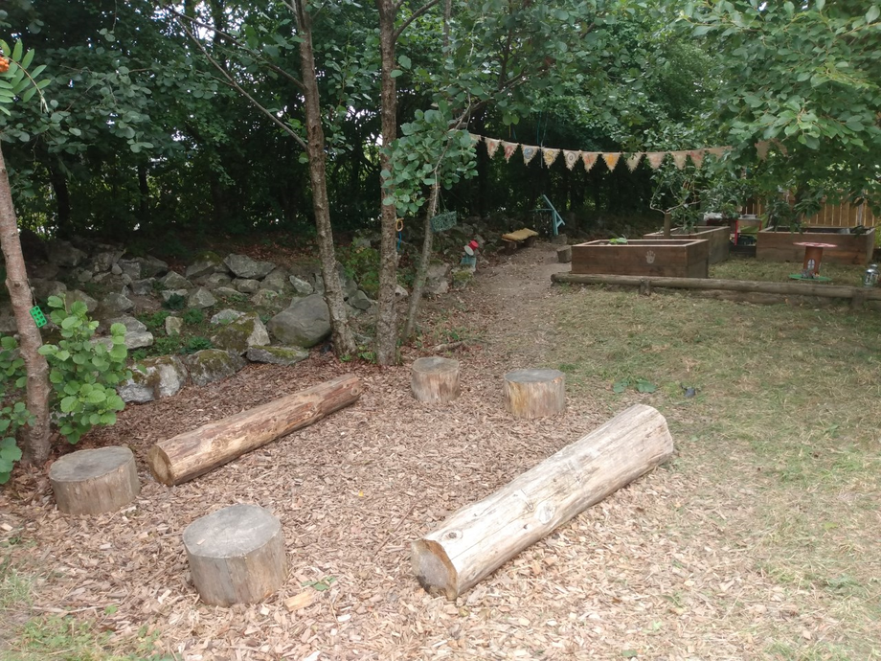

We have lots of fun up here, we run, climb, dig and build dens. We also enjoy stories and songs in the log circle.

This is our Headteacher Miss Soporova, we call her Miss S. She helps all the teachers and children in the school.
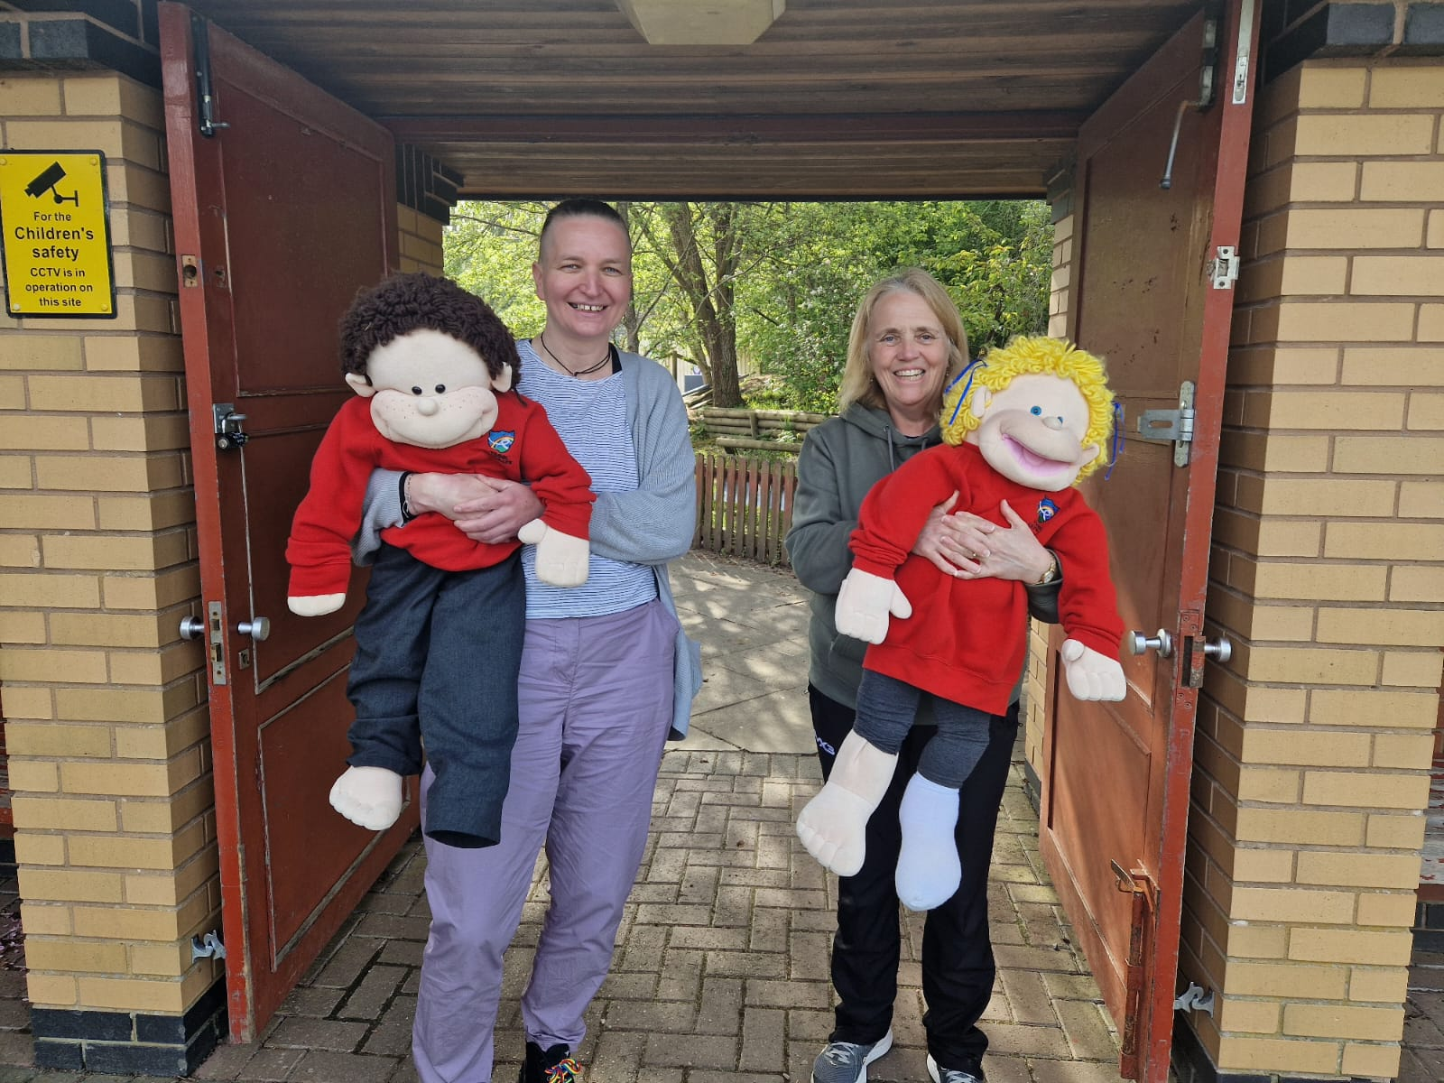

You will see Miss S at the school gates each morning. Don’t forget to wave and say hello!
We can’t wait for you to come and play very soon. We hope you have enjoyed this book.
Hwyl fawr for now!

