Reception Home Learning - Theme for this week – Brilliant books
Mrs N Blundell Week 3 11.5.20
 | Suggested activities
Literacy/Topic theme  Skills developed through these activities:  -Retell a a familiar story.  -Froggy fingers (correct pencil grip)  -Emergent writing/ letter formation.  - Segmenting sounds for writing.  - focused fine motor development through colouring/mark making.  -finding information from books and stories.  - Naming body parts.  Develop confidence in using welsh language in everyday activities. | Can you remember our topic work on ‘The Gingerbread Man’? Can you retell the story using Pie Corbett actions?  Draw a Gingerbread Man and label his body parts.  Can you sing ‘Heads, shoulders…´in welsh? | Draw a picture of a Gingerbread Man family. Can you give them all names?  Are they all the same size? If not, how are they different? | If you can log on to Giglets, have a look at all of the Fairy Tales I have added to your llibrary. What is your favourite fairy tale? Can you draw me a picture, and write the title of the story. | Can you retell the story of ‘The Three Little Pigs’.  Design a house that you think would keep the pigs safe from the wolf. Label the parts of your house that show it is strong and safe. | Design your own character to add to a fairy tale. What is their name? What do they eat? Can they do anything special?  Colour them in.
 | Useful Resources/tips
 | Log in to Giglets to read or listen to the story again. Use the sounds mats in resources to help you write the letters you need for your labels.  Remember to segment the sounds for writing. | Have a look at starfall.com. Remember The Gingerbread man game you can play on this site? Have a go at home. | If you having issues with Giglets please email me for support. If you would rather choose a book from home, that is fine. | Remember letter formation resources are on the website. | Encourage your child to name the colours they use in welsh and English if they can.
Numeracy/Science  Numeracy focus:  Counting objects.  Writing numbers .  Understanding simple addition.  Number recognition.  Recognising numbers/counting spots on a dice.  Count to ten in welsh. | Print out the Gingerbread Man colour by number sheets in the resources. I would love you to e mail me a picture of your finished artwork.  If you can’t print out, maybe you could draw your own? | In the resources below there is a Gingerbread man I spy game. Can you count the different items and write down the number. | In the resources there is a Gingerbread man dice game to play with one of your family. Roll the dice, and draw the correct part of your Gingerbread Man. | In the resources there are some Gingerbread addition sheets for you to try. If you can’t print out, you could make your own. | Can you draw the three bears from Goldilocks and the three bears. One must be big, one middle sized, and one small. Can you give them each a chair, a bowl, and a spoon.
 | Can you recognize each number? Do you know what the number is in welsh? | You can print it out, or simply count on screen. | If you can’t print it out, use these rules to draw your own:  Roll 1- eyes  Roll 2- buttons  Roll 3- mouth  Roll 4- nose  Roll 5- ears  Roll 6- scarf. |  | I would love to see your pictures.  Can you number the bears?
Wellbeing/Expressive Arts | Can you cut out some Gingerbread man paper dolls?  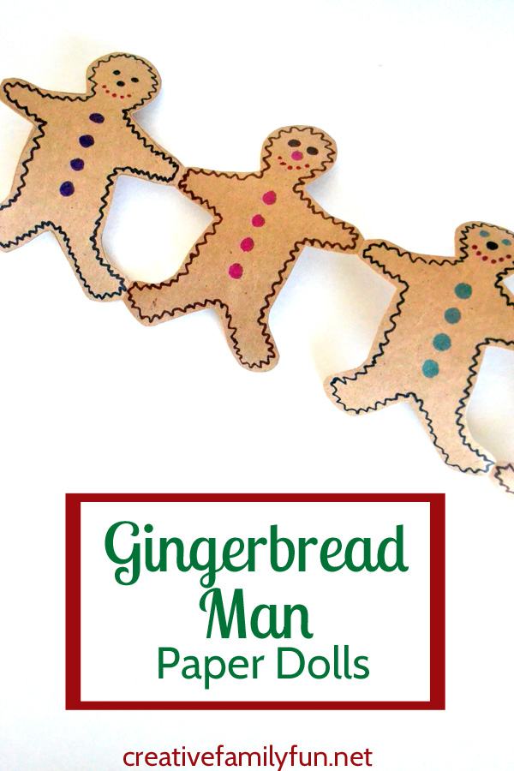 | Can you build a house for all three pigs to live in together. | Miss Wilke is busy at home looking after baby Maggie. Could you draw her a picture, or make her a card, as she misses you all so much. | Print off the fairy tale colouring pages in the resources, or draw your own. | Bake a ‘happy' if you have the ingredients. If not, design a cake you would like to bakegingerbread man, or make one out of playdough. Or paint or collage.
Wellbeing/Expressive Arts | Can you decorate each one differently?  How many do you have? Can you count them in welsh? | You could junk model, use lego, or anything else you like. | If you e mail me a photo, I can send them all to her to make her smile. | Remember froggy fingers, and careful colouring.
Please contact me with any queries/concerns nicb@cefnllys.powys.sch.uk. If you have any pictures you would like to e mail me, that would be lovely!

