- Tribe/Celts – Dosbarth Gwernen
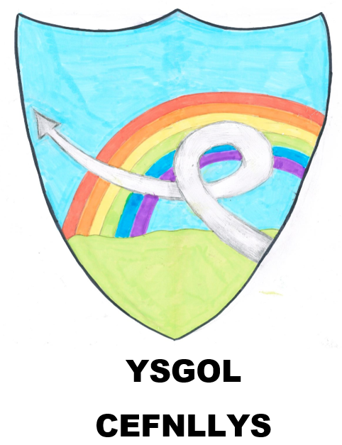

SUBJECT COVERAGE: Imaginative Learning Project for KS2 Children
Languages, literacy and communication: Instructions, Non - chronological reports, Recounts, Story writing, Poetry
Humanities: The Iron Age, tribes, fines and clans, artefacts, the Druids, Iron Age dress, family life, customs and beliefs, Roman invasion.
Expressive arts: Iron Age symbols and motifs, warrior re-enactment, weaving, Celtic art
Science and technology: Roundhouses, making clay artefacts, bread making, cooking on fires.
Mathematics and numeracy: Weighing and measuring.
Alternatively, write a diary entry together imagining that you are a Celtic farmer. What did you do today?

Why not visit the local library together and find out about the Celtic hoards found in Wales?
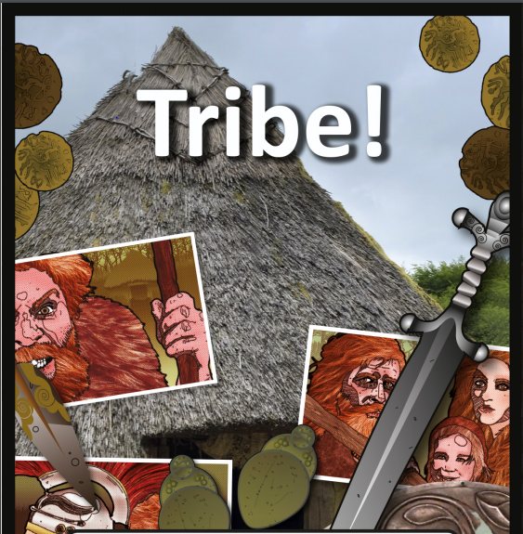

You could also create a quiz about Iron Age Celts and test others.
Find out about Celtic knots and create your own piece of artwork.

Who lived in the Iron Age? What kind of people were they? Explore these questions and more with this special project about the Iron Age Celts of Wales.
In this project, children will explore: Who the Celts were and when they lived, how they lived, Celtic customs and traditions, what happened to the Celts.

